# GLAB 330.2.2 - Standard Deviation

# 

**Introduction:**

**Standard Deviation** **(*σ*)** in statistics, typically denoted by **σ**, is a measure of how much a data set varies (dispersion) between values in a set of data. The lower the standard deviation, the closer the data points tend to be to the mean (or expected value), **μ**. In this lab, we will demonstrate how to calculate the standard deviation.

## Learning Objective:

By the end of this lab learners will be able to calculate the standard deviation.

**Given Dataset**

Imagine that we have the following data set representing the number of books read by five learners in a month:

|  |
| --- |
| **Number of Books (X)** |
| 2 |
| 4 |
| 4 |
| 4 |
| 5 |
| 5 |
| 7 |
| 9 |

**Instructions:**

Here are the steps to calculate the standard deviation:

1. **Calculate the mean (average) of the data set:**



1. **Calculate the squared differences from the mean for each data point:**

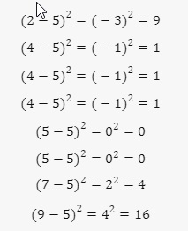

1. **Calculate the average of these squared differences (variance):**

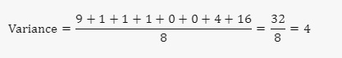

1. **Take the square root of the variance to get the standard deviation:**

## 

The standard deviation of the number of books read by these students is **2**. This means that on average, the number of books read by each student deviates from the mean by **2** books.

**Canvas Submission Instructions:**

* Upload your project to your GitHub account without setting it to private.
* Utilize the `README` file for any necessary additional instructions.
* Incorporate suitable comments throughout your project.
* Share the GitHub link on Canvas by clicking on the "Start Assignment" button located in the top-right corner of the Assignment page.

**Example Dataset :-**

**Calculating standard deviation of 15, 16, 19, 21, 23, 26, 30, 32, 36, 42.**

**1. Calculate the mean of the above data.**

15+16+19+21+23+26+30+32+36+42 = 260

Mean =260/10=26

Median = 23, 26

Mode = No mode

**2. Calculating the Sq differences**

(15-26)² = (-11)² = 121

(16-26)² = (-10)² = 100

(19-26)² = (-7)² = 49

(21-26)² = (-5)² = 25

(23-26)² = (-3)² = 9

(26-26)² = 0

(30-26)² = (4)² = 16

(32-26)² =(6)² = 36

(36-26)² = (10)² = 100

(42-26)² =(16)² = 256

3. **Calculate the average of the squared differences**

Variance = 121+100+49+25+9+16+36+100+256= 712/10 = 71.2

4. **Calculate Std Deviation**

Std Dev= Sqrt of Variance = **8.4**

The dataset deviates 8.4 from the mean.